1. Install [R](https://cran.r-project.org/) or [R Studio](https://www.rstudio.com/products/rstudio/download/#download) (recommended).

2. Create a folder named “LineNorm” in your Documents folder.

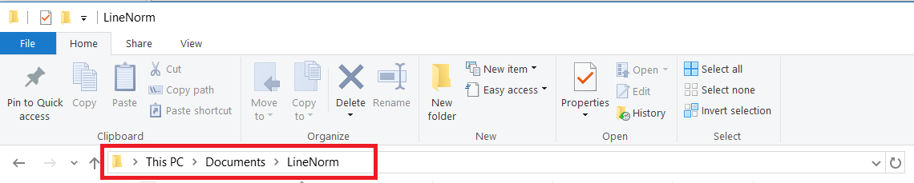

3. Copy the filename “[app](https://drive.google.com/drive/folders/0B2ZXeG2KBTpuV2dWT2NkemxTYUU)” and “[ChargeCodeTable](https://drive.google.com/drive/folders/0B2ZXeG2KBTpuV2dWT2NkemxTYUU)” to the LineNorm folder.

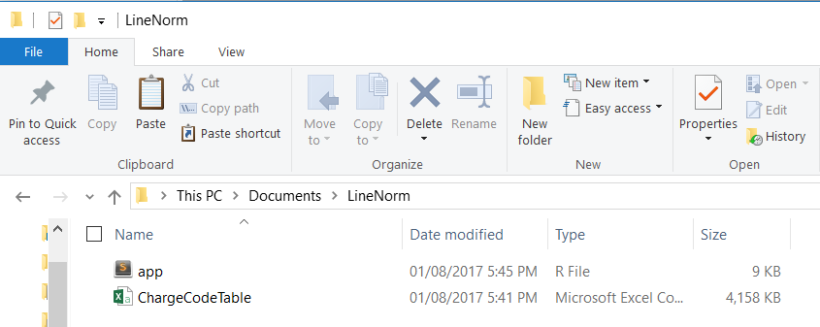

*Note: ChargeCodeTable is a combined list descriptions with charge code from different line norm templates (OneSourceLineItemV1, LineItemDEEDI, DataRefineryV1, etc). May need to put these lists in an SQL Database or any table that would automatically add those new charges assigned with charge codes.*

4. Open R or R Studio, copy and paste the code on the console and hit “enter”. This will install the packages needed for Line Norm tool to work. This code will be executed once.

*install.packages(c("RecordLinkage","stringdist","RODBC",”shiny”))*

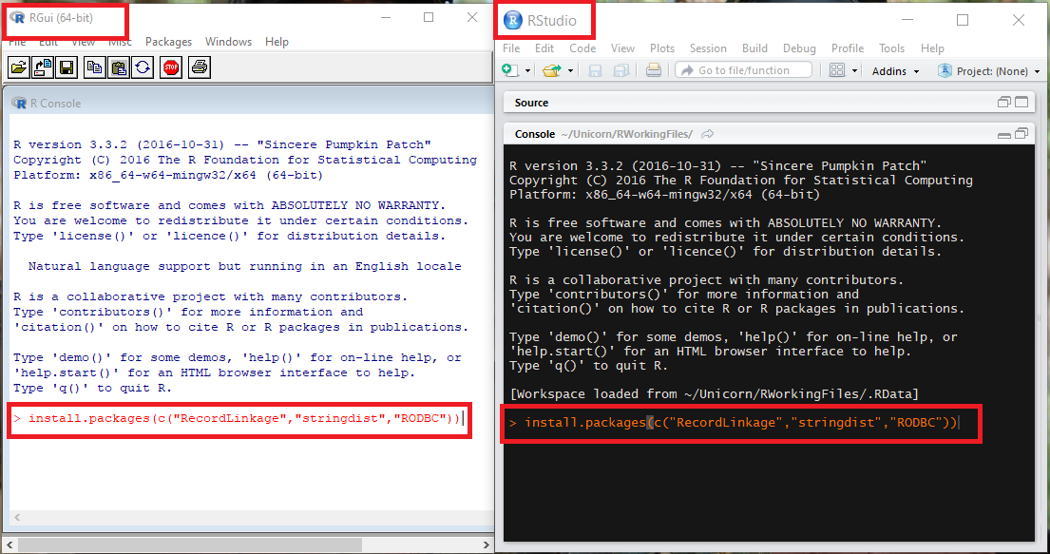

5. Copy and paste the codes start the tool. The codes need to be executed every time R or R Studio is restarted.

*library(shiny)*

*setwd("~/LineNorm")*

*runApp()*

6. Once code is executed, it will open a webpage where you can choose from a “drop down” list of customers you wish to generate a Line Norm exceptions.

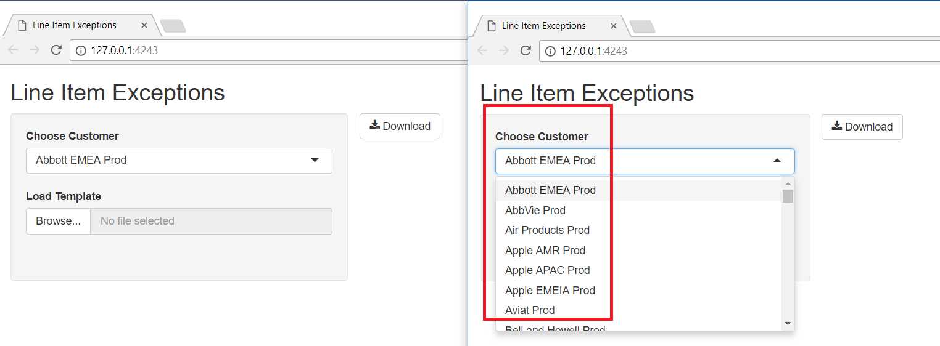

7. Click the “Download” button to generate a “.csv” file with all the list of Charge Description (vend_desc). Some of the charge description will be assigned with charged code and others will be blank. The charges description with no assigned charge code are result of the tool was able to find a match but the accuracy is less than 75%.

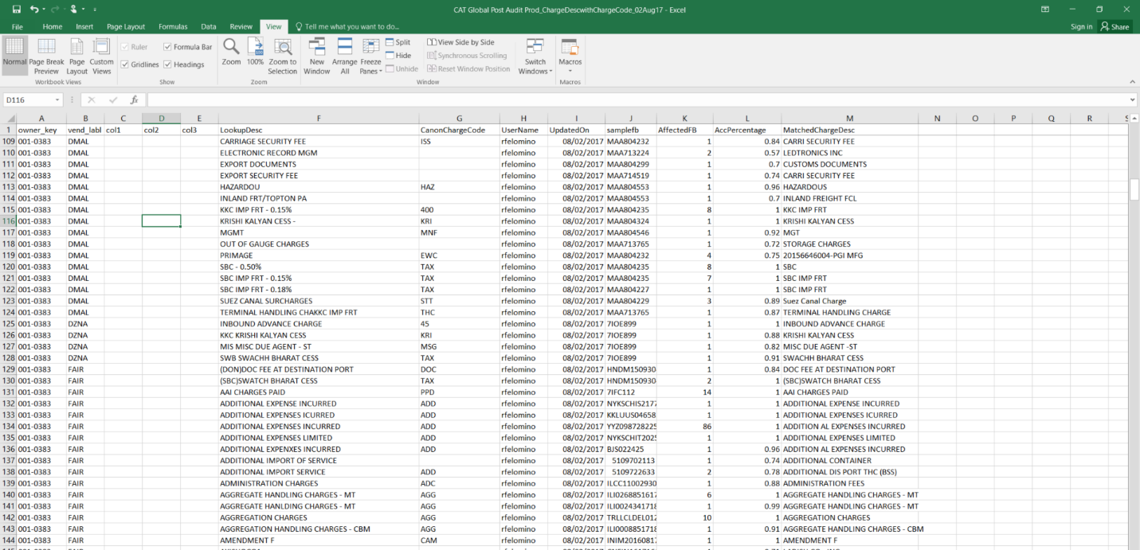

8. Review the result if correct charge code was assigned. If not, update it with the correct charge code. For the blank value, assign the appropriate charge code. Save the file as “.CSV” once completed.

9. Load the saved file by clicking “Browse” button.

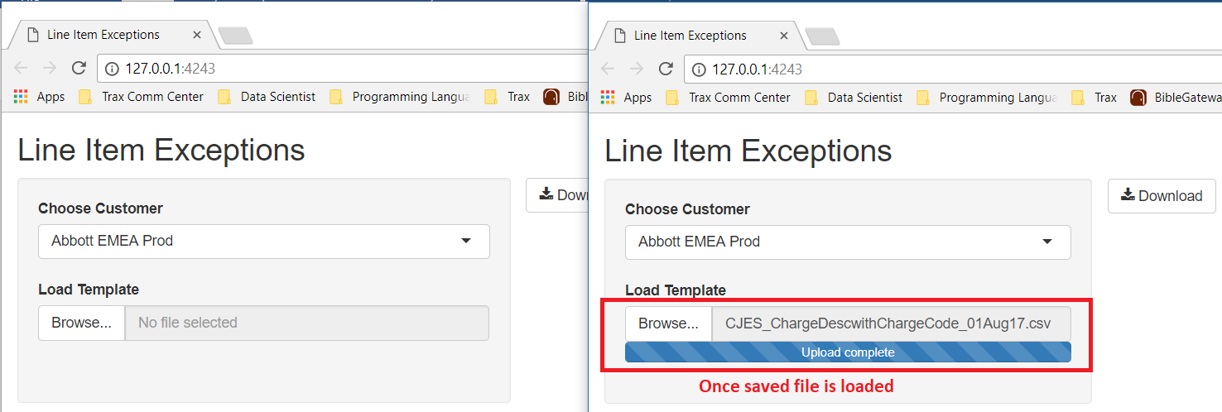

*Note: Loading the saved file will only update ChargeCodeTable. Saved file still needs to be added to the Line Norm Template the clear the exceptions.*

10. Transfer the charge description with charge code to the appropriate Line Norm Template the load the template.

11. Create a Jira ticket to process the affected batches. You may also manually process or process queue the batches if there is only few of them.